**Kubernetes Deployment with NGINX server**

* **Deploy** your application as quickly as possible.
* **Scaling** your application based on demands with Kubernetes Auto-Scaling Functionality which is **Orchestration**.
* Manage your **Microservices** with separate **Containers** for user management, product catalog and so on.
* Integrating Kubernetes with **CI/CD** tools to **automatically deploy** code changes.
* **Example:** Using **Jenkins** to build **Docker** images and deploy them to a **Kubernetes** cluster whenever there is a new commit in the repository.

**Here is demo Configuration. You are welcome to scale your Deployment with same yaml File.**

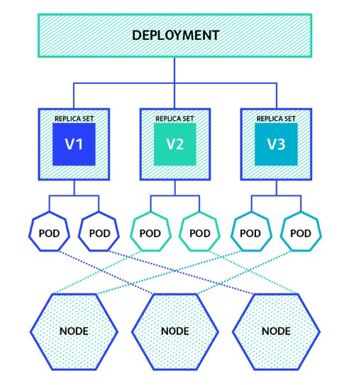

**Prerequisites:**

* Install Minikube and kubectl command-line tool.

**Step 1:** Start Minikube

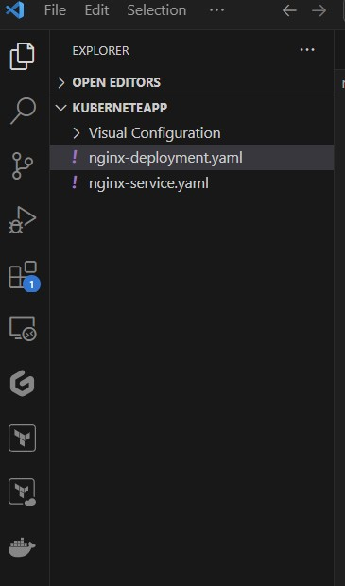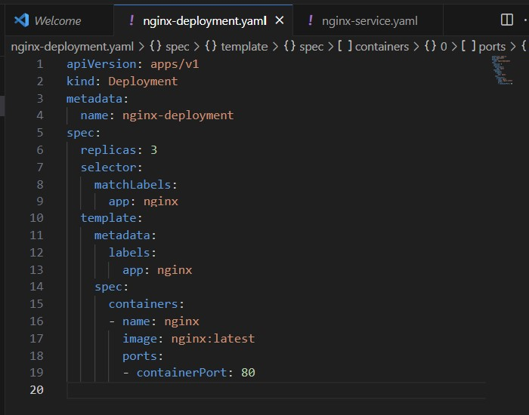**Step 2:** Create your Project hierarchy accordingly visual screenshot below.

Apply this configuration and create deployment: **kubectl apply -f nginx-deployment.yaml**

Apply this configuration and create service: **kubectl apply -f nginx-service.yaml**

Access your NGINX Web Server: **minikube ip**

Verify the Deployment and Service: **1) kubectl get deployments 2) kubectl get pods 3) kubectl get services**

**Congratulation.** All are done with your NGINX Server Deployment. Hope that it helps**😊😊**